Project Design Phase-II
Data Flow Diagram & User Stories

Date | 30 September 2026
Team ID | SWTID-2026-1691
Project Name | AI BlogNest API
Maximum Marks | 4 Marks

Data Flow Diagrams:
A Data Flow Diagram (DFD) is a traditional visual representation of the information flows within a system. A neat and clear DFD can depict the right amount of the system requirement graphically. It shows how data enters and leaves the system, what changes the information, and where data is stored.
Level 0 DFD (Context Diagram) – AI BlogNest API:
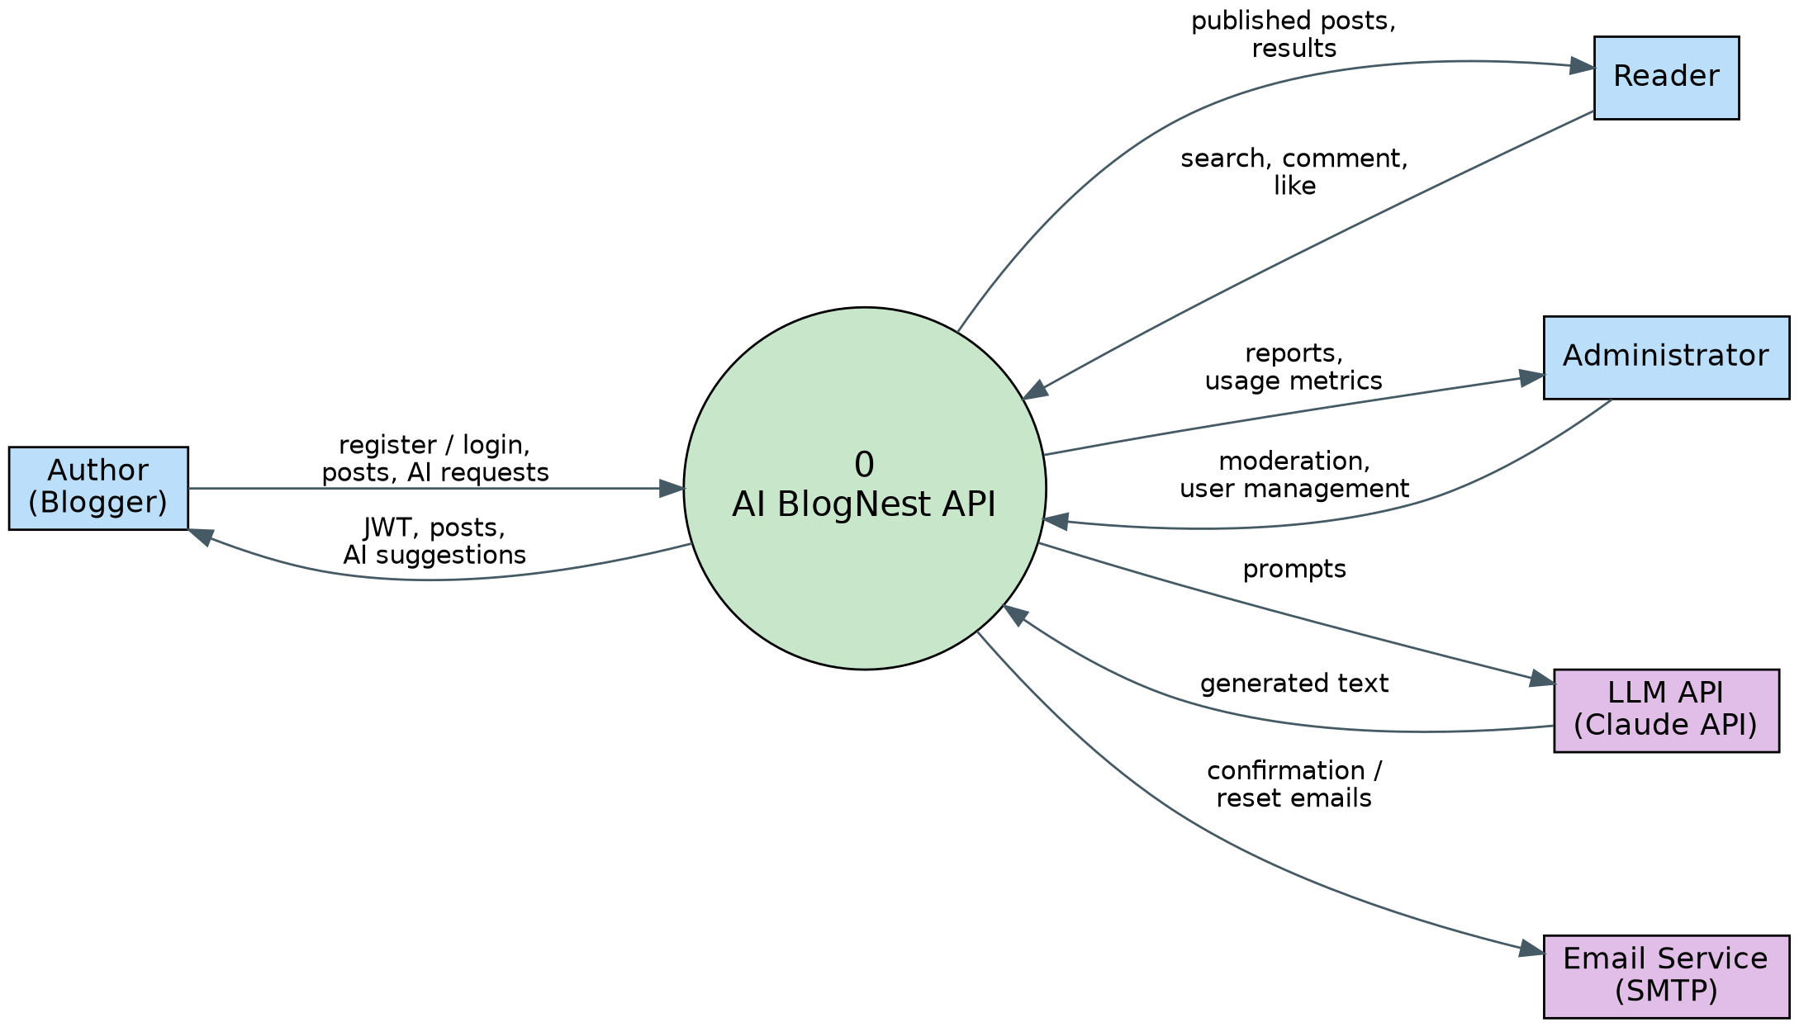
Level 1 DFD – AI BlogNest API:
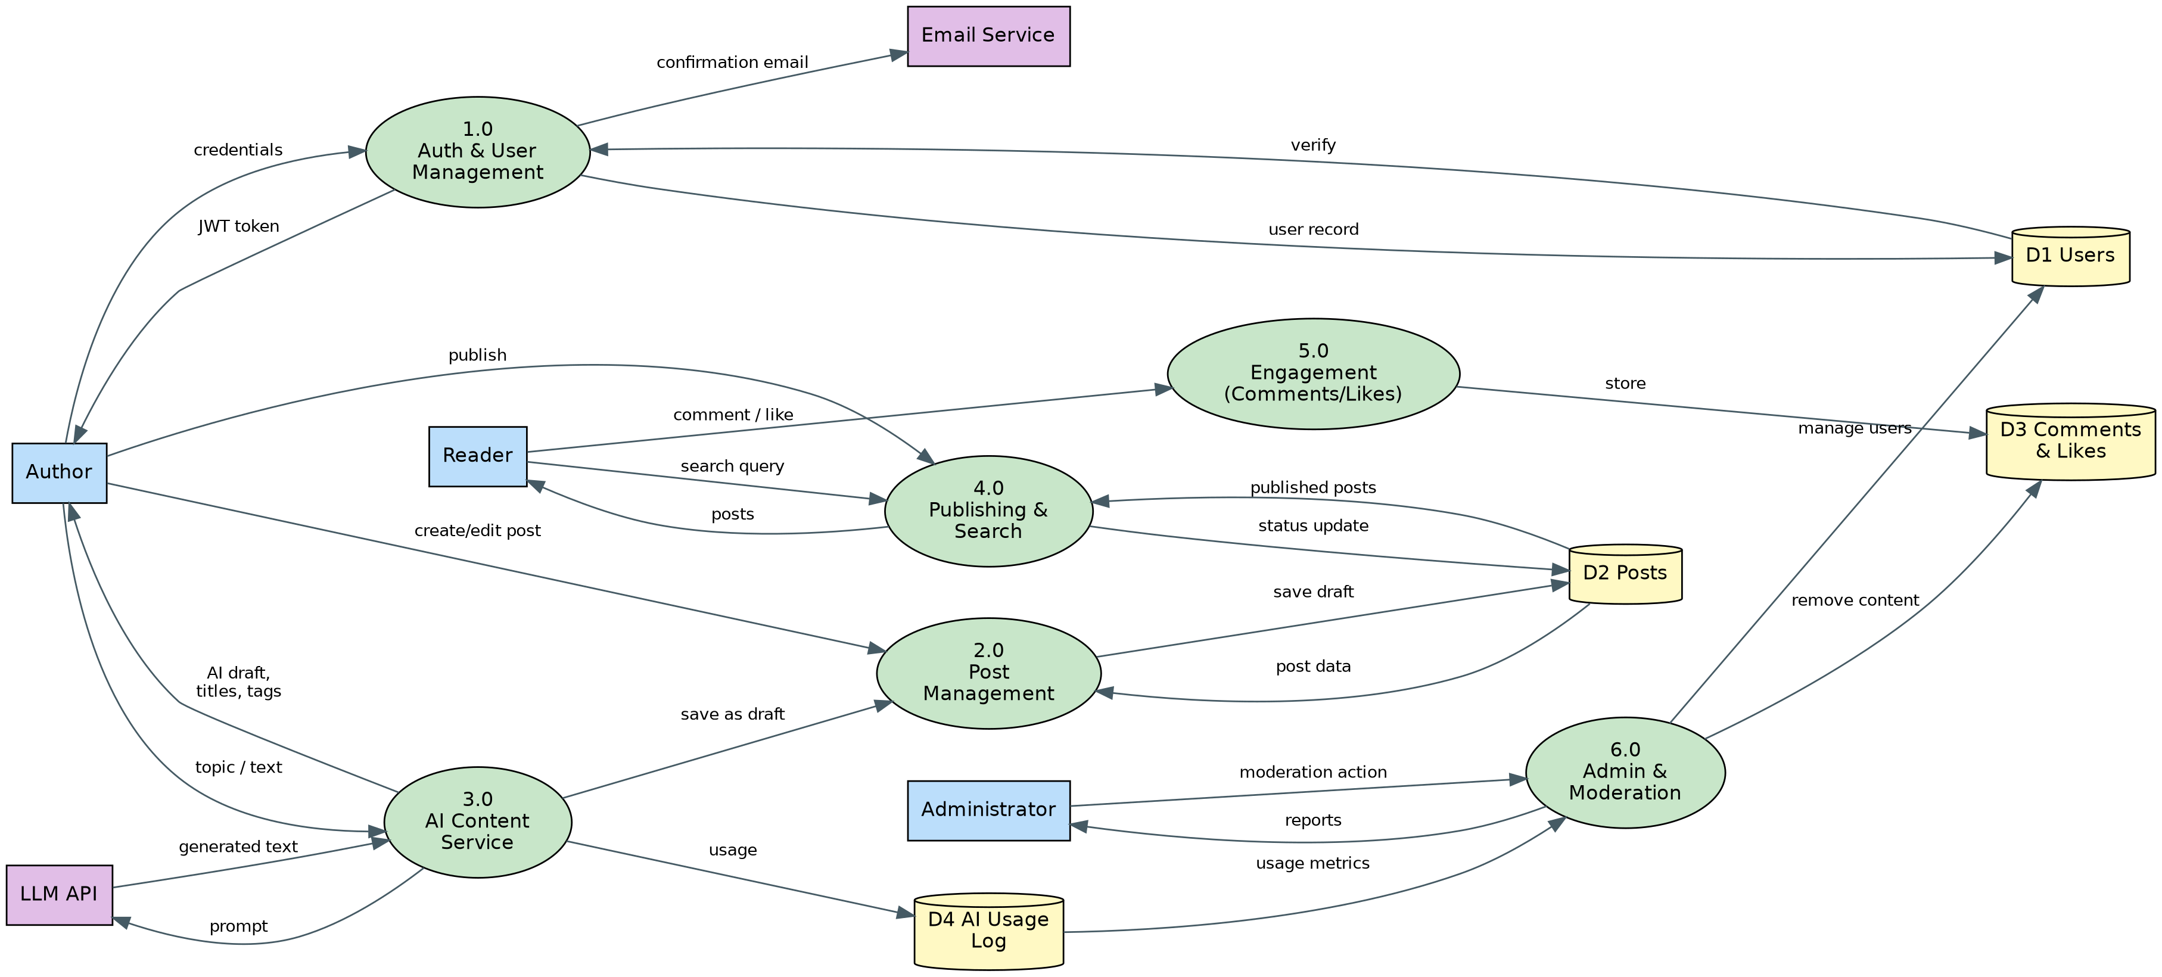

User Stories
Use the below template to list all the user stories for the product.
User Type | Functional Requirement (Epic) | User Story Number | User Story / Task | Acceptance criteria | Priority | Release
Author | Registration | USN-1 | As an author, I can register by entering my email, password and confirming my password. | Account is created and I get a success response. | High | Sprint-1
Author | Registration | USN-2 | As an author, I will receive a confirmation email once I have registered. | I receive an email and can verify my account through the link. | High | Sprint-1
Author | Login | USN-3 | As an author, I can log in with my email and password. | I receive a valid JWT and can access protected endpoints. | High | Sprint-1
Author | Post Management | USN-4 | As an author, I can create, edit, view and delete my blog posts (saved as drafts). | Post is saved as a draft and only I can modify or delete it. | High | Sprint-1
Author | Profile | USN-5 | As an author, I can update my profile (name, bio, avatar). | Updated details are saved and returned in my profile. | Medium | Sprint-1
Author | AI Content Assistance | USN-6 | As an author, I can generate a draft or outline by giving a topic and keywords. | AI draft is returned and saved as an editable draft. | High | Sprint-2
Author | AI Content Assistance | USN-7 | As an author, I can improve my text (grammar, tone, rewrite) using AI. | Improved text is returned and my original stays unchanged until I accept it. | High | Sprint-2
Author | AI Content Assistance | USN-8 | As an author, I can get AI-suggested titles, SEO meta description and tags for a post. | Suggested titles, description and tags are returned for my post. | Medium | Sprint-2
Author | Publishing | USN-9 | As an author, I can publish, unpublish or schedule a post. | Post status changes correctly and published posts appear publicly. | High | Sprint-3
Reader | Browse & Search | USN-10 | As a reader, I can browse and search published posts by keyword, tag, category or author. | Matching posts are returned with pagination. | High | Sprint-3
Reader | Engagement | USN-11 | As a reader, I can comment on and like posts. | Comment or like is saved and shown on the post. | Medium | Sprint-3
Administrator | Moderation | USN-12 | As an administrator, I can review and remove inappropriate posts and comments. | Removed content is no longer visible and the action is logged. | High | Sprint-4
Developer (API consumer) | API Access | USN-13 | As a developer, I can generate an API key and I am protected by rate limits. | API key works for requests and excess requests receive HTTP 429. | Medium | Sprint-4
Administrator | Usage Monitoring | USN-14 | As an administrator, I can view platform and AI usage metrics. | A usage report per user and per day is returned. | Medium | Sprint-4
Developer (API consumer) | Documentation | USN-15 | As a developer, I can use interactive API documentation and get clear error messages. | Swagger UI lists all endpoints and errors return a consistent JSON format. | Medium | Sprint-4

